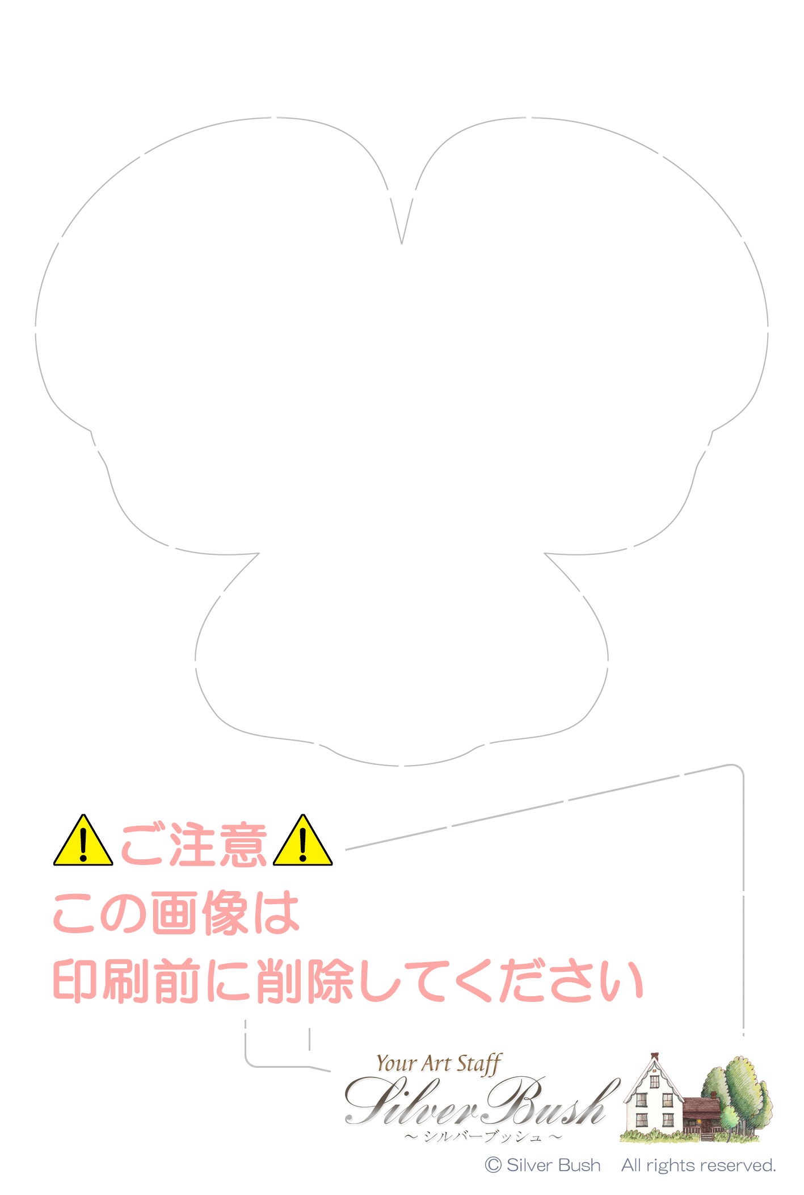
○○ ○○様
Taro & Hanako
June 6th, 2015

