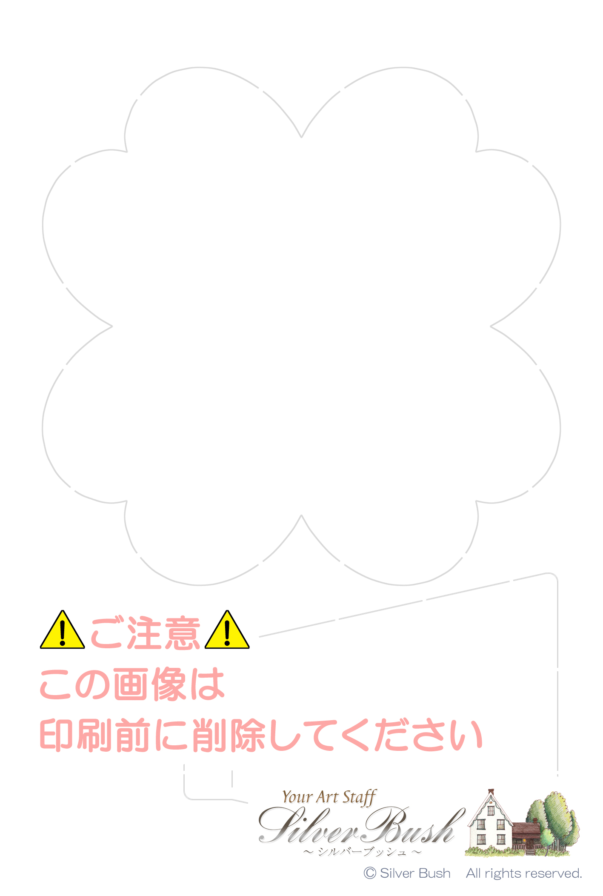
○○ ○○様

Taro & Hanako
September 15th, 2014

